Practice Assignments Multiforms and Debugging

Quiz questions, practical assignments and

answers to quiz questions

**Version:** 0.1 **Last updated:** 10 oktober 2023

Contents

[1 Practical assignments: Windows Forms App 3](#_Toc147863644)

[1.1 Programming Assignment 1: Random moving a car 3](#_Toc147863645)

[1.1.1 Case description 3](#_Toc147863646)

[1.2 Programming Assignment 2: Dice rolling 4](#_Toc147863647)

[1.2.1 Case description 4](#_Toc147863648)

[1.2.2 Screenshot 4](#_Toc147863649)

[1.2.3 Provided material 4](#_Toc147863650)

[1.3 Programming Assignment 3: Lottery 5](#_Toc147863651)

[1.3.1 Case description 5](#_Toc147863652)

[1.3.1 Screenshot 5](#_Toc147863653)

[1.3.2 Provided material 6](#_Toc147863654)

[1.3.3 Additional features 6](#_Toc147863655)

# Practical assignments: Windows Forms App

## Programming Assignment 1: Random moving a car

Difficulty:

The assignment covers the following learning goals:

* Working with a Timer
* Working with a PictureBox
* Introduce randomness in an application

### Case description

In the lesson ‘Intro Object and Classes’ you created an application to allow a user to move a PictureBox through your screen (see Figure 3: GUI of Moving a car).

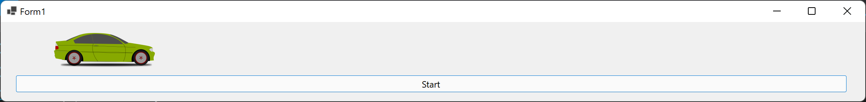

Figure 3: GUI of Moving a car

Your task is to modify the movement logic so that the car moves to a random direction instead of only go from left to right.   
To challenge yourself a bit, can you make it in such a way that it only changes to a random direction after having moved 50 pixels in a certain direction (e.g. after moving at least 50 pixels to the left, a new random direction is chosen and only after at least 50 pixels in that direction a new random direction is chosen).

## Programming Assignment 2: Dice rolling

C:\Users\874156\Desktop\flatastic-icons-part-1-by-custom-icon-design\png\16x16\star-3_5.pngDifficulty:

The assignment covers the following learning goals:

* Introduce randomness in an application
* You are able to make use of multiple forms

|  |  |
| --- | --- |
| C:\Users\874156\Desktop\flatastic-icons-part-1-by-custom-icon-design\png\48x48\alert.png | This assignment focusses on the .NET’s Random-class and multiple forms. For this reason, you do not need to create your own classes. |

### Case description

Create a new Windows Form Application to simulate the rolling a dice with six faces (i.e. a regular dice). The user should be able to specific how many rolls should be performed. After clicking a button, the application should generate the specified amount of random numbers and show a form for each of the generated numbers with an image representing the result.

*Figure 4: Possible result after rolling* depicts the GUI with a possible result with two dice rolls. The images to show can be downloaded from Canvas.

### Screenshot

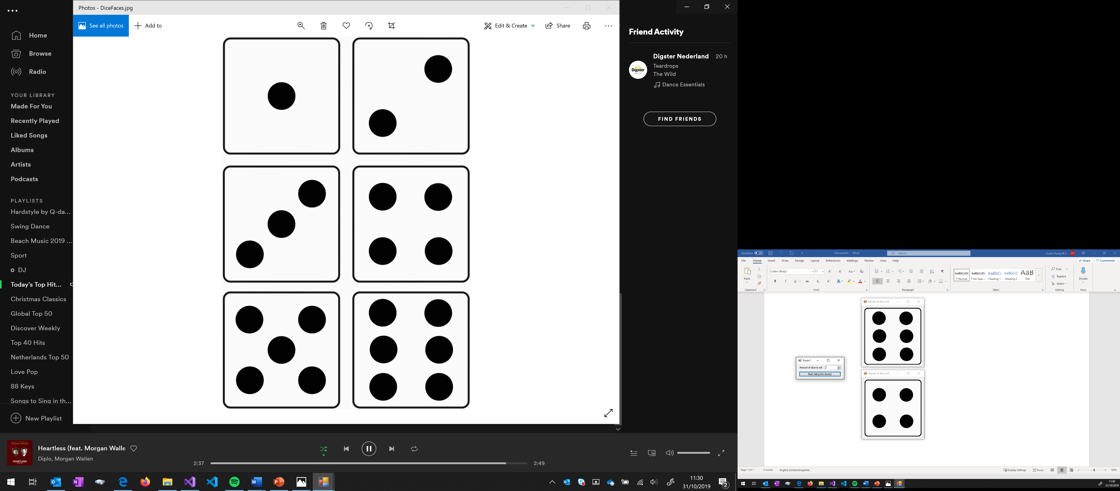

Figure 4: Possible result after rolling

### Provided material

In the folder PractialMaterial the file *DiceRolling\_Images.zip* contain the images with six dice faces.

## Programming Assignment 3: Lottery

Difficulty: 

The assignment covers the following learning goals:

* Concepts covered this far

### Case description

In this assignment, you are asked to develop an application for a lottery. Examples of a lottery are Lotto and Bingo. For example, the Lotto:

*If you play Lotto, you have to choose 6 lucky numbers out of the numbers 1, 2, 3, . . . , 44, 45.   
The Lotto-machine has 45 balls which are numbered 1, 2, 3, . .. , 44, 45.   
Every week the Lotto-machine draws 6 balls. If the numbers of the drawn balls are equal to your lucky numbers, you win the big prize. An example result of a Lotto-drawing could be: "24, 2, 6, 37, 15, 45"*

In this example, a Lotto-drawing can be stored in an array of 6 numbers. The given example is based on 6 balls, but in another lottery the machine could draw a different number of balls.

In this assignment you will create one application that serves two kinds of lottery:

1. Some lotteries draw all numbers without the interference of a presenter. The numbers are shown one by one in a certain time lapse.
2. Another kind of lottery draws all numbers at once and shows them all on the screen (or on their website or . . .).

With this application, the user should be able to create a lottery, to draw the required numbers and then show information on the screen; also see Figure 5: Possible lottery GUI to get an idea how the application could look like.

### Screenshot

Figure : Possible lottery GUI

### Provided material

For this application you should create one class. The public methods are provided below, but which instance variables and private methods you need is for you to determine.   
We suggest to first implement *draw all numbers at once* before doing *draw next number*.

|  |  |
| --- | --- |
| Class **Lottery** | |
| *CONSTRUCTOR* | Should initialize the *Lottery*-object with a *max value* and *nr of wanted numbers*.  *Max value*: the lottery has balls numbered from 1up and including the *max value* (in the above example *Max value* is 45)  *Nr* *of wanted numbers:* this value represent how many number should be draw (in the above example it is 6). |
| *METHOD* public int[] DrawAllNumbers() | This method should return an array of integers containing all the numbers that should be drawn.  Make sure that the numbers are unique and randomly chosen. |
| *METHOD* public int DrawNextNubmer() | This method should return an integer representing the drawn number.  Make sure that the numbers are unique and randomly chosen. In this case, unique numbers means that it can not be the same as previously drawn numbers. For example, when *DrawNextNumber()* was invoked three times returning *35, 2* and *78*, then the next invocation of *DrawNextNumber()* cannot return *35, 2* or *78*. |
| *METHOD* public bool IsLotteryFinished() | This method should return a Boolean indicated whether all numbers have been drawn.  Make sure it returns the correct value independently of whether all number are drawn in one go or done one-by-one. |

### Additional features

For the *Lottery* class, it is possible to call *DrawNextNubmer()* and then DrawAllNumbers(). Can you modify you code in such a way that when this happened the remining numbers are drawn/returned?

When the *Max value* (e.g. 25) and *Nr of wanted numbers* (e.g. 22) you will run in to an efficiency error. Can you determine why this is and how you can fix this bug?   
Note that this can be a hard feature to implement so do not feel discouraged when you cannot come up with a solution.